**Lab 8**

**20k-0157**

Task1A

#include <stdio.h>

#include <stdlib.h>

/* run this program using the console pauser or add your own getch, system("pause") or input loop */

int factorial(int n);

int main() {

int n;

printf("Enter number: ");

scanf("%d",&n);

printf("Factorial of %d = %ld", n, factorial(n));

return 0;

}

int factorial(int n) {

if (n>=1)

return n*factorial(n-1);

else

return 1;

}

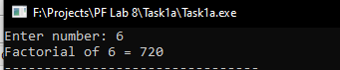

Task1B

#include <stdio.h>

#include <stdlib.h>

/* run this program using the console pauser or add your own getch, system("pause") or input loop */

int noOfDigits(int n1);

int main()

{

int n,counter;

printf("Input a number : ");

scanf("%d",&n);

counter = noOfDigits(n);

printf("The number of digits in the number is : %d \n\n",counter);

return 0;

}

int noOfDigits(int n1)

{

static int counter=0;

if(n1!=0)

{

counter++;

noOfDigits(n1/10);

}

return counter;

}

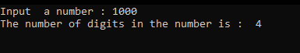

Task2

#include <stdio.h>

#include <stdlib.h>

/* run this program using the console pauser or add your own getch, system("pause") or input loop */

int powr(int x,int y);

int main(int argc, char *argv[]) {

int bv,pw,a;

printf("Enter base value ");

scanf("%d",&bv);

printf("Enter power ");

scanf("%d",&pw);

a=powr(bv,pw);

printf("the value of %d to the power %d is %d",bv,pw,a);

return ;

}

int powr(int x,int y)

{

int ans;

if(y==0){

return 1;

}

else

ans=x*powr(x,y-1);

return ans;

}

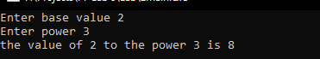

Task3

#include <stdio.h>

#include <stdlib.h>

/* run this program using the console pauser or add your own getch, system("pause") or input loop */

void swap(int *a,int*b)

{

int temp;

temp=*a;

*a=*b;

*b=temp;

}

int main(int argc, char *argv[]) {

int x, y;

printf("Enter the value of x and y\n");

scanf("%d%d", &x, &y);

printf("Before Swapping = %d %d\n", x, y);

swap(&x,&y);

printf("After Swapping = %d %d", x, y);

return 0;

}

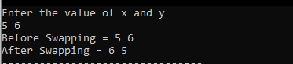

Task4A

#include <stdio.h>

#include <stdlib.h>

/* run this program using the console pauser or add your own getch, system("pause") or input loop */

void max(int *a,int *b)

{

if(*a>*b)

printf("Max number is %d ",*a);

else

printf("Max number is %d",*b);

}

int main(int argc, char *argv[]) {

int num1,num2;

printf("Enter two numbers\n");

scanf("%d %d",&num1,&num2);

max(&num1,&num2);

return 0;

}

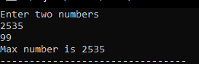

Task4B

#include <stdio.h>

#include <stdlib.h>

/* run this program using the console pauser or add your own getch, system("pause") or input loop */

void add(int *a,int *b)

{

*a=*a+*b;

}

int main(int argc, char *argv[]) {

int num1,num2;

printf("Enter two numbers\n");

scanf("%d %d",&num1,&num2);

add(&num1,&num2);

printf("Addition is %d",num1);

return 0;

}

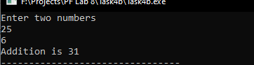

Task5

#include <stdio.h>

#include <stdlib.h>

/* run this program using the console pauser or add your own getch, system("pause") or input loop */

void func(int *sq,int *cube,float *sqroot)

{

int n;

printf("Enter number; ");

scanf("%d",&n);

*sq= n*n;

*cube= n*n*n;

*sqroot = sqrt(n);

}

int main(int argc, char *argv[]) {

int sq,cube;

float sqroot;

func(&sq,&cube,&sqroot);

printf("Square root is = %.3f\nCube is = %d\nSquare is = %d",sqroot,cube,sq);

return 0;

}

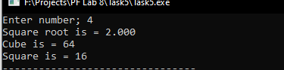

Task6

#include <stdio.h>

#include <stdlib.h>

/* run this program using the console pauser or add your own getch, system("pause") or input loop */

void func(int *sum,float *sd,float *avg,int array[])

{

int n=5,i,j;

float submission=0,a=0;

for(i=0;i<=n;i++)

{

*sum=*sum+array[i];

}

*avg=*sum/n;

for(j=0;j<=n-1;j++)

{

a=((array[j]-*avg)*(array[j]-*avg));

submission=submission+a;

}

*sd=sqrt(submission/n);

}

int main(int argc, char *argv[]) {

int sum=0;

float sd=0,avg=0;

int arr[5],k;

printf("Enter values\n");

for(k=0;k<=4;k++)

{

scanf("%d",&arr[k]);

}

func(&sum,&sd,&avg,arr);

printf("SD = %.3f\nSum = %d\navg = %.1f ",sd,sum,avg);

return 0;

}

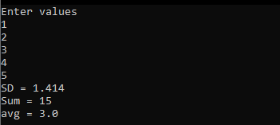

Task7

#include <stdio.h>

#include <stdlib.h>

/* run this program using the console pauser or add your own getch, system("pause") or input loop */

int main(int argc, char *argv[]) {

int arr[5],i,j;

printf("Enter values;\n");

for(i=0;i<=4;i++)

{

scanf("%d",&arr[i]);

}

printf("-----------------------\n");

for(j=4;j>=0;j--)

{

printf("%d\n",*(arr+j));

}

return 0;

}

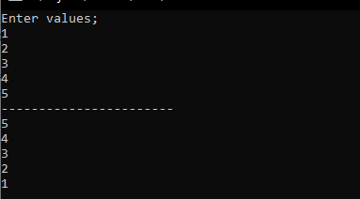

Task8

#include <stdio.h>

#include <stdlib.h>

/* run this program using the console pauser or add your own getch, system("pause") or input loop */

int compare(int x,int y)

{

if(x > y)

return 1;

if(x < y )

return -1;

if(x==y);

return 0;

}

int (*fp_func)(int x,int y);

int main(int argc, char *argv[]) {

int a,b,ans;

printf("Return 1 if a > b\nReturn 0 if a = b\nReturn -1 if a < b\n");

printf("\nEnter a & b; \n");

scanf("%d%d",&a,&b);

fp_func = &compare;

ans=(*fp_func)(a,b);

printf("\n%d",ans);

return 0;

}

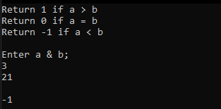

Task9

#include<stdio.h>

int sumEvenIndex(int *j)

{

int c[10];

int i,sum = 0;

for(i = 0;i < 10;i++)

{

c[i] = *j;

j++;

}

for(i = 0;i < 10;i += 2)

{

sum=sum + c[i];

}

return sum;

}

int sumOddIndex(int *k)

{

int c[10];

int i,sum = 0;

for(i = 0; i < 10; i++)

{

c[i] = *k;

k++;

}

for(i = 1; i < 10; i += 2)

{

sum = sum + c[i];

}

return sum;

}

void sortArray(int b[])

{

int i,j,temp=0;

for ( i = 0; i < 10; i++)

{

for ( j = 0; j < 10; j++)

{

if (b[j] > b[i])

{

temp = b[i];

b[i] = b[j];

b[j] = temp;

}

}

}

printf("Array sorted:\n");

for(i=0;i<10;i++)

{

printf("%d ",b[i]);

}

}

int main()

{

int a[10], i;

printf("Enter Elements: \n");

for(i = 0;i < 10; i++)

{

scanf("%d", &a[i]);

}

printf("Sum of even index: %d\n", sumEvenIndex(&a[0]) );

printf("Sum of odd index: %d\n", sumOddIndex(&a[0]));

sortArray(a);

}

